**Final Project: Project Scope**

Group 4

Sfwrtech 3PR3

**Group Members**

|  |  |
| --- | --- |
| **Name** | **Student Number** |
| Natesh Mayuranathan | 400051783 |
| Diqing Shu | 001205132 |
| Lois Chu | 001427491 |
| Sanket Patel | 400047782 |

**Project Proposal**

Customer Relationship Manager (CRM)

The CRM is a console based application that will allow the user, a customer service representative, to manage information about their company’s clients as stored within an SQLite database. The system allows users to create, update, and delete clients, cases, and companies. Further, the system will allow users to view lists of clients which can be sorted, as well as filtered by company. Client information includes their name, title, email address, phone number, and physical address, as well as notes. Company information includes their name, address, and sector (e.g. pharmaceutical, manufacturing, IT, etc). Cases refer to issues or questions customers raise about orders and general inquiry. Case information includes a unique ID, a type (a separate object in the database), the customer and agent involved in the case, and details of the case (e.g. what was ordered, the issue the customer raised, or the question that was asked).

**Project Scope**

Database Schema

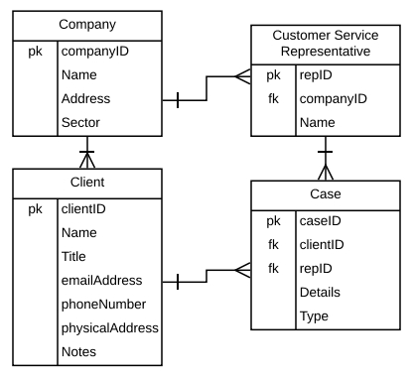

User Experience

When the user launches the CRM application, they will be required to be registered into the database by entering in a unique ID and the company they are associated with. They will then be presented with the main menu, involving options to Search the database, Open an existing case, start a New Case, or Quit.

If they choose to Search, the user will be offered the choice to search by Company, Client, or Case. After choosing which category to search by, the user will be able to enter keywords to identify the Company, Client, or Case required. If the search returns more than one Company, Client, or Case, certain attributes will be displayed to aid in the user identifying which is needed. Attributes for Company include the company name and sector. Client Name, Title and associated Company Name would be displayed for multiple results of a Client. Case ID, Client Name, Representative Name and Representative Name would be shown for Case. The user will then be able to select opening a record for more details. If the search produces no results, a message will be displayed indicating this, and the user is asked if they would like to search again or return to the main menu.

When opening a record, all attributes are displayed, and the user is given the option of editing them. Editing Cases is covered below. All attributes of Companies and Clients are Editable. The user is prompted for which attribute they wish to edit. If the attribute does not exist, they are asked to enter a different attribute. When a valid attribute is selected, new values may be entered until a newline character is input. Once finished, changes will be displayed and the user is given the choice of either confirming their changes or restarting their edit. Once confirmed, the user is asked whether they wish to edit other attributes or if they wish to save all changes to the database. Once the user saves their chances to the database, they are asked whether they wish to view other records or return to the main menu. If the first option is selected, they are taken back to search screen.

If they choose to Open an Existing Case, the application will prompt the user for the case ID and the user will be able to enter a known case ID and be directed to the case details. If successful, it will be inquired if the user wishes to edit the details. If so, the user will be asked to choose which attribute to edit. Only the Case’s Details and Type are editable. Editing follows the workflow listed above.After changes are saved to the database, the user is given the option to edit another case or return to the main menu.

In the event the Case does not exist in the database yet, the user may select the option of creating a New Case. The user will then be asked if it is for an existing client. If the client exists, the application will confirm that the client and related company records exist and will inform the user. The user will then be allowed to enter the case type and its pertinent details. When finished, the entry will be displayed to the user for the user to confirm or edit its details. Once the record is entered into the database, the user will be informed of the created case ID and will prompt if he or she wishes to return to the main menu.

If the client does not exist, the application will ask if the associated company is within its records. If the company exists, the application will confirm this and prompt the user to enter its attribute values, display the values once again for the user to confirm or edit, and inform the user of the new client ID. The attributes the user will need to enter include the client’s title, email address, phone number, physical address, and notes. If the company does not exist, the user will be asked to enter its attribute values, display the values for the user to confirm or edit, and inform the user of the new company ID. Company attributes that the user will be required to enter consist of the company’s address and sector. Upon having an existing company and client within the database’s records, the user may continue to create a new case. Attributes the user will enter are details and type. The database will automatically associate the appropriate customer service representative’s ID and client ID.

When the user returns to the main menu, the same options are displayed. If they choose to Quit, they are asked to confirm, and if they do so, the application exits to the operating system.